Available Topics - [REAKT] Project REAKTOR

Page / - last modified by Alexander Schulz-Rosengarten on 2024/09/23 11:12

[REAKT] Project REAKTOR
last modified by Alexander Schulz-Rosengarten
on 2024/09/23 11:12

Table of Contents
Overview of topics (WIP)
Goals
Scope
Related Work/Literature
Involved Languages/Technologies
Supervised by

The REAKT project (https://reakt.sh/ & https://www.schiene-m-l.de/) aims at developing new mobility concepts to reactivate rural rail lines. This project will evolve around developing an autonomous rail vehicle, the REAKTOR, to flexibly provide on-demand service on single track lines. A prototype will be built in 1:32 scale for 45 mm gauge, as well as a full scale version for the railway track Malente-Lütjenburg.
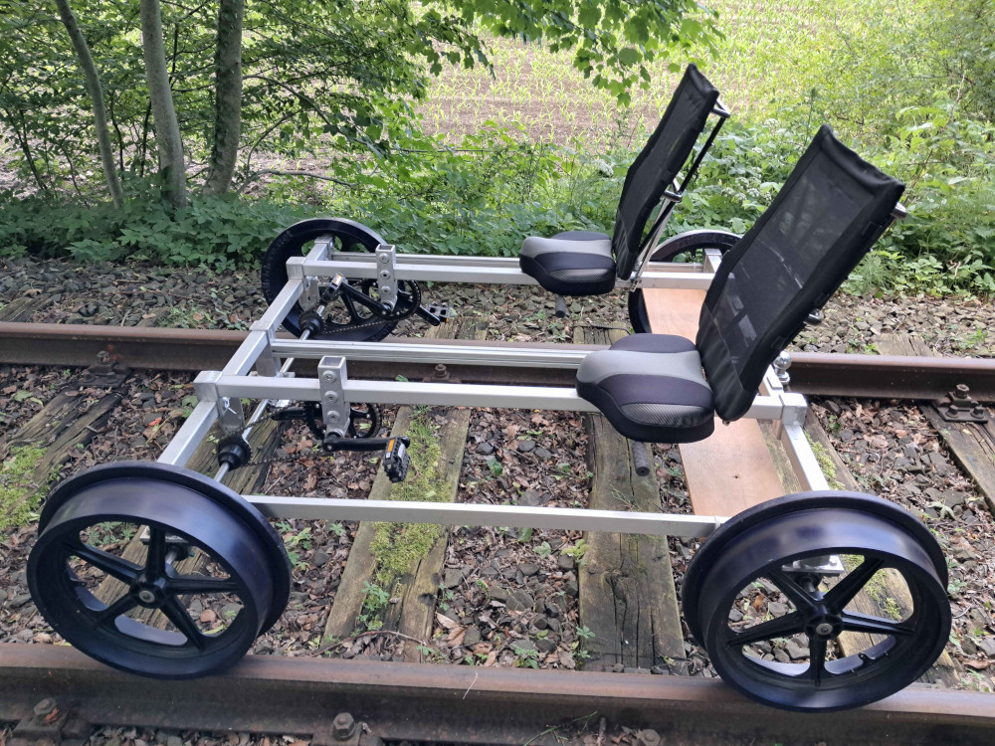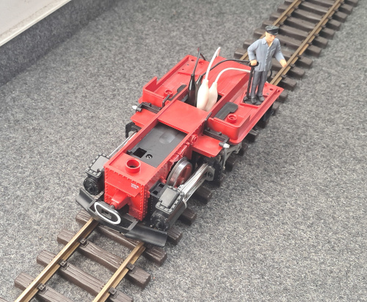
(left) a railbike, the foundation of the upcoming autonomous draisine & (right) a stripped down LGB engine for a 45mm model track.
Kick-off meeting on Monday 7th Oct. at 10am in room 1115 CAP4

Overview of topics (WIP)
The solutions in all topics should be scalable for both demonstrators!
1. An end-user app and management system for on-demand train service [already assigned (App part only)]
This topic may be split up into two theses/project participants (app & management)
- A mobile app to call a train to a desired location and communicate desired destination
- Locations drawn from GNSS and appropriate abstraction for 1:32 scale for station-less entry or predefined locations
- Management of multiple on-demand trains on a single track line
- Schedules for cooperative passenger pick up
- Provisions for passenger transfer on open track ("Begegnungsverkehr", see concept art here)
- The inter train communication concept maybe based on a central or decentralized structure
2. An autonomous train controller with risk analysis using STPA [already assigned]
- Control of an autonomous passenger train model (conceptually working for both demonstrators)
- Capability for passenger transfer on open track (safe docking procedure; "Begegnungsverkehr", see concept art here)
- Risk analysis for the controller using STPA (http://psas.scripts.mit.edu/home/get_file.php?name=STPA_handbook.pdf)
- Safe behavior model generation using PASTA (https://marketplace.visualstudio.com/items?itemName=kieler.pasta)
- Assumes preprocessed sensor input and destination determination (see other topics)
3. AI-based obstacle detection for autonomous train control using image recognition [already assigned]
This topic will be jointly advised with the AG Distributed Systems
- Sensor processing of a train-mounted camera to detect objects (potential obstacles)
- Tasks will involve:
  - Sensor mounting on the demonstrator
  - Collection of data (images, videos)
  - Labeling of data to enable training (esp. for small scale model)
  - Training of AI
  - Evaluation of quality
  - Live testing
- Step-wise evaluation of the influence of vehicle speed on the detection quality
- Evaluate applicability and influence of training data due to different environments for the demonstrators (i.e. indoors vs. outdoors)
- (Optional) Trajectory detection to categorize safety threads of moving obstacles
- (Optional) Evaluate performance on different hardware, e.g. Rasberry Pi vs. AI hardware
- (Optional) Test and evaluate on the edge deployment
- For interfacing with the controller, the sensor should provide an assessment how safe the area in front of the train is, such that the controller can adjust its speed.
- Potential hardware (subject to changes):
  - https://www.raspberrypi.com/documentation/accessories/camera.html
  - https://www.axis.com/de-de/products/axis-p1455-le
4. Classic and AI-based distance sensing for autonomous train control using different sensors
This topic will be jointly advised with the AG Distributed Systems
- Explore and evaluate different sensors and processing techniques for distance measuring in rail vehicles
- Compare quality, ranges, and reliability w.r.t speed and size (demonstrator)
- Sensors and approaches:
  - Ultrasonic sensor
  - Single camera with AI image recognition
  - (Multiple cameras)
  - (LiDAR)
  - (Sensorfusion)
- Potential hardware (subject to changes):
  - https://www.elektronik-kompendium.de/sites/praxis/bauteil_ultrasonic-hcsr04p.htm
  - https://www.pi-shop.ch/lidar-ld06-lidar-module-with-bracket-entwicklungskit-fuer-raspberry-pi-sbc
  - https://www.blickfeld.com/de/produkte/cube-1/
5. A digital twin for an autonomous on-demand train service [already assigned]
Note: Tight interfacing with other topics
- A digital twin for an autonomous passenger train
- A virtual rebuild of the track using an 3D engine (i.e. Unreal Engine)
- Simulation capabilities to test and replay behavior (virtual environment)
- (Optional) Monitoring system for the state and location of the real vehicle
- (Optional) Monitoring and economic analysis of on-demand service operation (integration/interfacing of management system)
- (Optional) Reliability analysis/statistics to ensure transparency of autonomous operation
6. Remote control for rail vehicles [already assigned]
This topic will be jointly advised with the AG Distributed Systems
Note: Tight interfacing with other topics
- Remote control of speed and brakes (interfacing with controller)
- Live streaming of camera data and other sensors
- Evaluation and setup of a wireless communication network with a high reliability
- (Optional) Construction of a remote control panel
- (Optional) Augmented reality integration to simulate training scenarios
7. A standalone sensor box for monitoring rail vehicles [already assigned]
This prototype will be tested (only) using the full-scale demonstrator and is intended for monitoring non-autonomous vehicles (not the REAKTOR)
- Development of a sensor array to monitor rail vehicle operation
- It should serve as a plugin solution inside the train's cockpit for monitoring operation and as preparation for autonomous control
- Design for wireless communication of collected data
- Possible sensors:
  - GPS
  - Accelerometer
  - Camera
- Analysis of data for autonomous driving
- Potential integration into digital twin infrastructure

Goals
- TBA for each topic individually

Scope
Bachelor's or Master's Thesis, or Master's Project, with varying requirements to scientific scope.

Related Work/Literature
- https://reakt.sh/
- https://www.schiene-m-l.de/

Involved Languages/Technologies
- TBA for each topic individually

Supervised by
Alexander Schulz-Rosengarten
als@informatik.uni-kiel.de

