Archive - Real Time Project WS 16/17 Home

Page / - last modified by uru on 2016/08/03 14:32

Real Time Project WS 16/17 Home
last modified by uru
on 2016/08/03 14:32

Table of Contents
Layout Project
References

This project is offered as MSP1101: Masterprojekt - Echtzeitsysteme/Eingebettete Systeme (Layout) (080098). Master students may subsequently write a thesis building on results of the project.
Kick-Off Meeting
If you would like to join this project, you need to attend the kick-off meeting on October 26th at 10:00am. The meeting will be held in CAP4, room 1115.

Layout Project
Graph layout algorithms are widely used to have computers generate visualizations of graph-like information. To that end, a graph layout algorithm generates a two-dimensional layout that consists of positioning data for nodes (represented as closed shapes) and routing data for edges (represented as curves). There are several approaches for designing graph layout algorithms [1,2].
As a participant of this practical, you will work together with other students in order to extend specific layout algorithms or design visualizations using the Java programming language.
The algorithms will be implemented according to the layout interface of the ELK and KIELER projects, which is based on the Eclipse platform. The results may be published as part of either of the two open source projects.
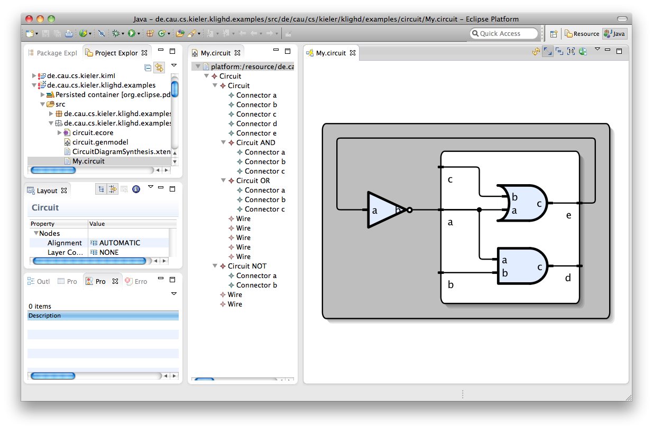
This is KLighD showing a graphical view of a textually specified electric circuit.
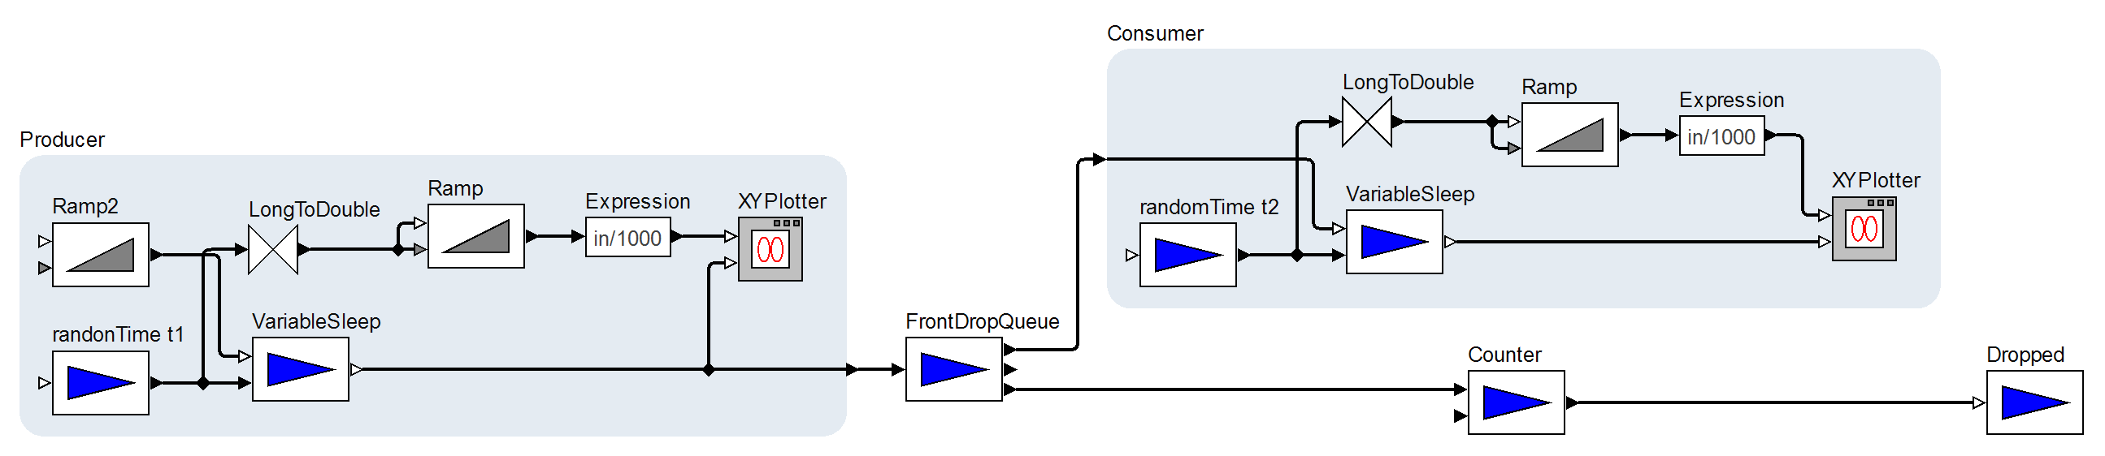
A diagram laid out with our ELK Layered algorithm.
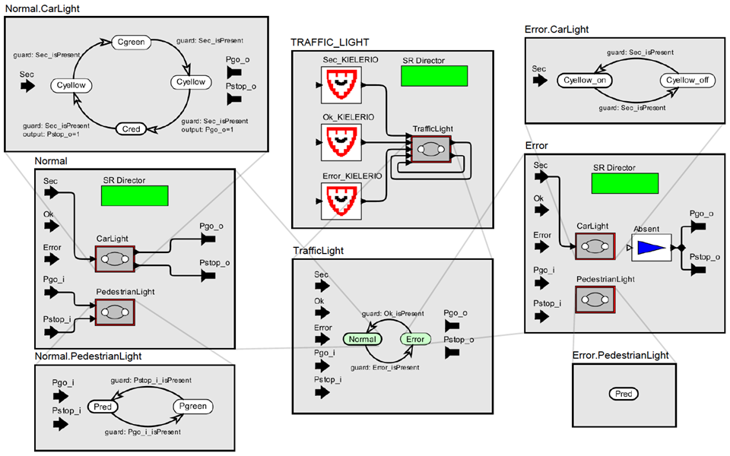
A visualization of a Ptolemy diagram's hierarchy.
Responsible for this project is Ulf Rüegg. If you need assistance, feel free to send an email or ask for an appointment.

References
[1] Giuseppe Di Battista, Peter Eades, Roberto Tamassia, and Ioannis G. Tollis. Graph Drawing: Algorithms for the Visualization of Graphs. Prentice Hall, 1998.
[2] Tamassia, Roberto. Handbook of graph drawing and visualization. Chapman and Hall/CRC, 2013. (Online: https://cs.brown.edu/~rt/gdhandbook/)
[3] Christoph Daniel Schulze and Miro Spönemann and Reinhard von Hanxleden. Drawing Layered Graphs with Port Constraints. Journal of Visual Languages and Computing, Special Issue on Diagram Aesthetics and Layout, 2014.
318

