Archive - 2019 Railway Project

Page / - last modified by Richard Kreissig on 2025/01/30 12:19

2019 Railway Project
last modified by Richard Kreissig
on 2025/01/30 12:19

Table of Contents
Welcome!
About the Railway Project
Contact us:
Important Dates

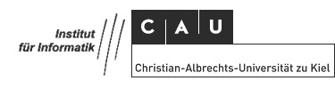
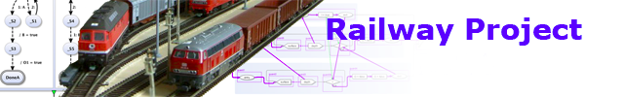
This project is offered as bachelor project as well as master project

Welcome!
Welcome to the Confluence Wiki of the Railway Project. What this Wiki is all about:
- It's the place where we post important information on the project, such as due dates and similar information.
- It's also the place where we post tutorials. You will spend the first part of the project working through the tutorials before starting your individual projects.
- And finally, it's the place where each group will document their project.

About the Railway Project
This project employs model-based-design and the synchronous approach to control a Model Railway. The application is a local physical existent model railway installation where multiple trains shall be driven concurrently on the installation. Development of this project is done in a model-based-design, using SCCharts, which merges control flow (Statecharts) and data flow.
This project is done in a practical laboratory course at the Christian-Albrechts University of Kiel in the Department of Computer Science within the Real-Time and Embedded Systems Group.
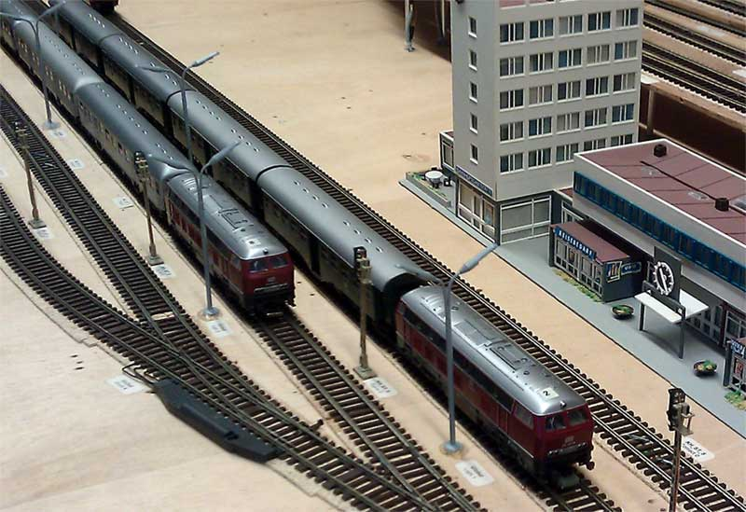

Contact us:
The project is supervised by the following university staff. Please contact us if you have questions regarding the project.
- Prof. Dr. Reinhard von Hanxleden (rvh@informatik...)
- M.Sc. Niklas Rentz (nre@informatik...)
- M.Sc. Sören Domrös (sdo@informatik...)
- M.Sc. Alexander Schulz-Rosengarten (als@informatik...)

Important Dates
Datum | Raum | Termin
22.02.19 14:00 - 14:30 | Labor 1114/15 | Introduction
10.04.19 11:45 - 12:30 | Labor 1114/15 | Kick-Off Meeting

