2014 Railway Project - Introduction

Page / - last modified by Richard Kreissig on 2025/01/30 12:05

Introduction
last modified by Richard Kreissig
on 2025/01/30 12:05

Table of Contents
University Staff
Introduction
Model Railway Installation
To Go Further...
Organisation of the Project

- Introduction
- University Staff
- Introduction
- Model Railway Installation
  - To Go Further...
- Organisation of the Project

University Staff
This project is supervised by the following university staff.
- Prof. Reinhard von Hanxleden
- Dipl.-Inf. Christian Motika
- Dipl.-Inf. Steven Smyth

Introduction

Model Railway Installation
The model railway in H0 scale has a size of 18 squaremeters and a track length of 127 meters. It is named after a mountain pass in canada because the original track layout was mimicking the track layout of this real-world pass. The layout nowadays [1] got a little bit simplified.
The electrical part of the railway is a standard analogue one where the trains get controlled by simple DC power transferred by the track lanes. Hence the track scheme is divided into 48 distinct blocks, which have lengths between 51 and 459 cm. This way more than 8 trains can be operated concurrently at the installation. Additionally there are 80 magnetic sensor contacts, 28 switch points, 58 semaphore signals, 24 lamp posts and a railroad crossing with two bars and a bell. All together there are 245 sensors and actuators.

To Go Further...
- Technical Documentation: http://www.informatik.uni-kiel.de/~railway/
- Railway Lecture Summary: http://rtsys.informatik.uni-kiel.de/~rt-teach/ws11/v-synch/lectures/lecture05a-handout4.pdf (slides 24-48)
- Kickoff Talk: Sildes
- KIELER: Downloads and Information
- SCCharts: SCCharts (pre 1.0) Overview + Introduction and Examples
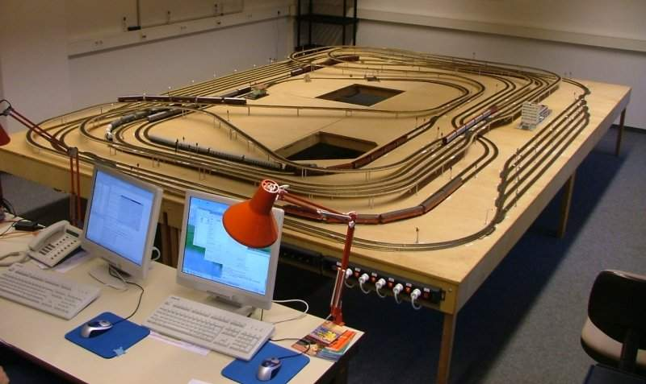

Organisation of the Project

The project is a practical laboratory course. It is supervised by university staff members and the developer team comprised all attending undergraduate students in the 3rd year and above. The organization is to be documented in this wiki.
Since SCCharts is a newly developed programming language at the Chair of Real-Time Systems and Embedded Systems here at the Kiel University, a short feedback loop between language designers (university staff) and project participants (students) is desired. Of course this should be a two-way communication, meaning that problems and constructive criticism should be provided by the students whereas fixes and information should be delivered by the supervisors.

