Archive - Google Maps for Models - WiSe 2020/21

Page / - last modified by Richard Kreissig on 2023/09/06 14:35

Google Maps for Models - WiSe 2020/21
last modified by Richard Kreissig
on 2023/09/06 14:35

Table of Contents
Welcome!
About the Browsing Project
Contact us:
Results
Important Dates

Inf-MP-ES: Masterprojekt Echtzeitsysteme/Eingebettete Systeme (Google Maps for Models)

Welcome!
Welcome to the Confluence Wiki of the Masterprojekt offered by the Real Time and Embedded Systems group on the topic of Google Maps for Models, henceforth referred to as the Browsing Project. What this Wiki is all about:
- It's the place where we post important information on the project, such as due dates and similar information.
- It's also the place where we post or link to tutorials. You will spend the first part of the project working through the tutorials before starting your individual projects.
- And finally, it's the place where each group will document their project.

About the Browsing Project
We all know and love how the information in Google Maps is presented while browsing. When looking at a country, only central points of interest such as big cities, rivers, country borders and streets connecting everything are highlighted in an intuitive way. If a user wants to know more about a specific area, they just zoom in and more information gradually pops into view while keeping the visible information always at a level of interest of that area. The shown map is just a filtered visual model of everything in the world presented in a context dependent way to the user.
We use other models with a lot of information where it can be confusing to identify individual components clearly when visualized with our current technology stack and using static diagrams. With this project we want to identify how the concepts for browsing of Google Maps can be applied to diagrams of different kinds of models when using the Visual Studio Code-alike technology Theia, its diagram framework Sprotty, a framework for automatic diagram generation called KLighD and automatic layout of the diagrams with ELK.
This project is done in a practical laboratory course at the Christian-Albrechts University of Kiel in the Department of Computer Science within the Real-Time and Embedded Systems Group.

Contact us:
The project is supervised by the following university staff. Please contact us if you have questions regarding the project.
- Prof. Dr. Reinhard von Hanxleden (rvh@informatik...)
- Niklas Rentz (nre@informatik...)

Results
This project has concluded, the resulting project report can be found here:
dwo_mp_11pt.pdf
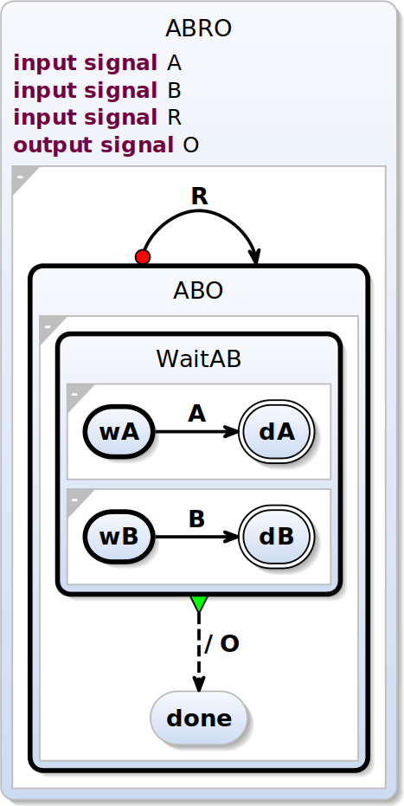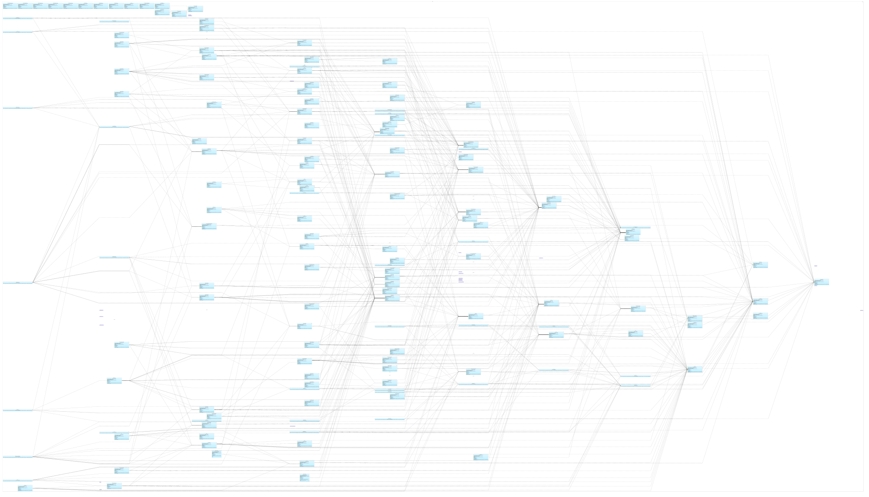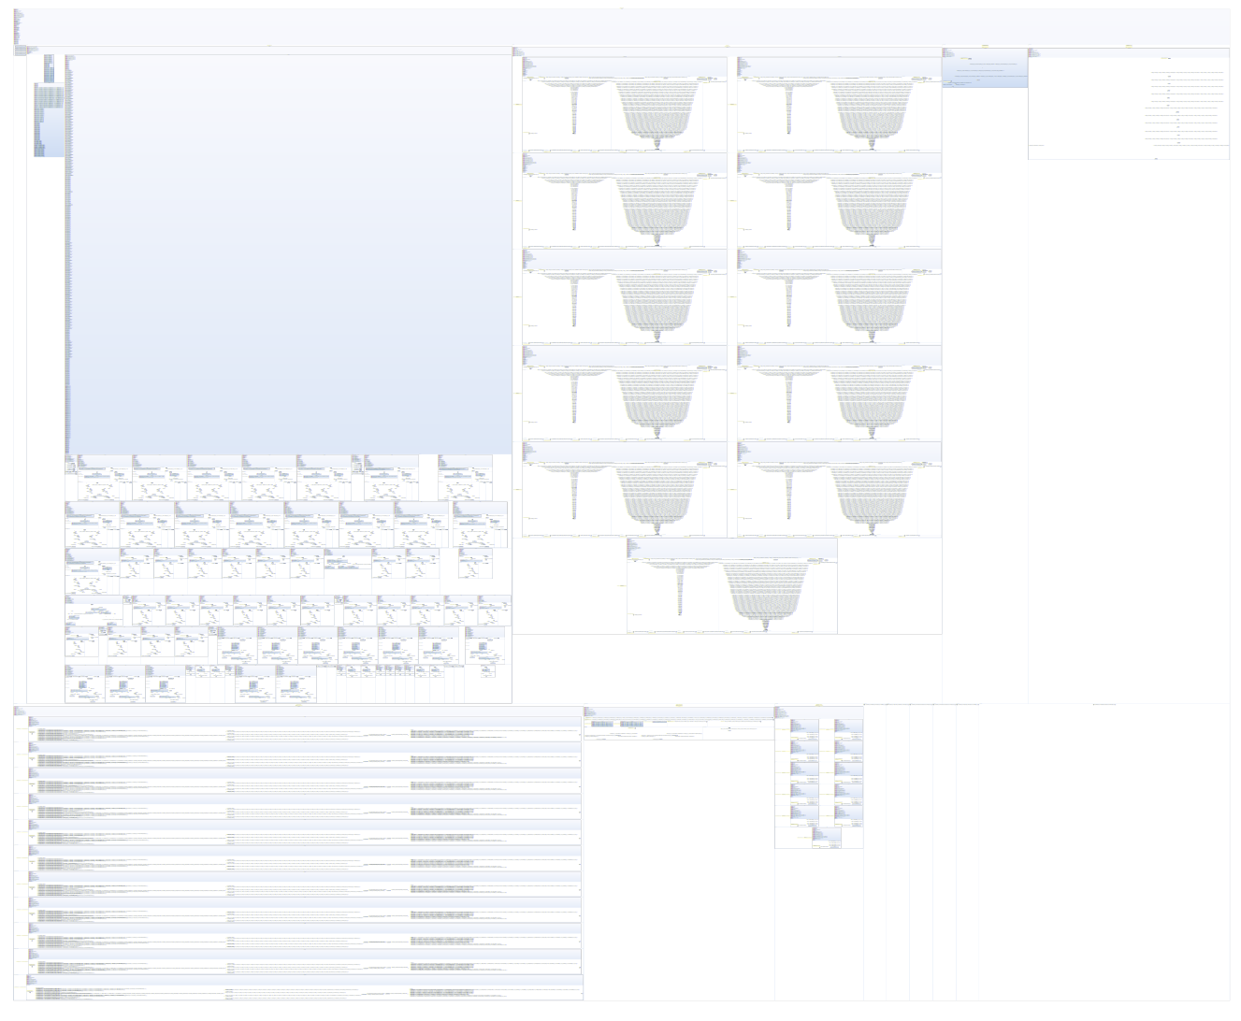

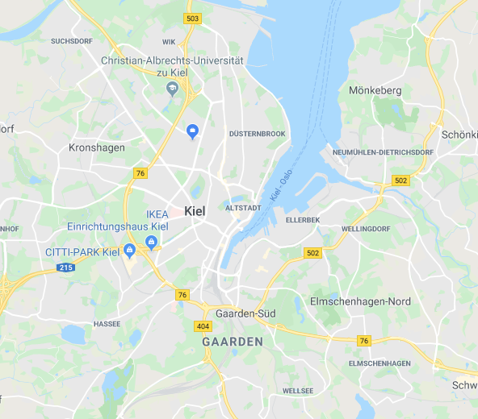

Important Dates
Date | Room | Event
Nov. 3, 2020, 12:45 PM | Online (See note on the top of the page) | Kick-Off Meeting

