SCCharts (Deprecated/Historical Documentation & Features) - The SC Language (SCL)

Page / - last modified by Richard Kreissig on 2023/09/14 11:11

The SC Language (SCL)
last modified by Richard Kreissig
on 2023/09/14 11:11

Table of Contents
Project Overview
SCL - SC Language

Project Overview
Responsible:
- Christian Motika
- Steven Smyth

SCL - SC Language
SCL is a minimal language adopted from C, Java and Esterel and can be interpreted as Sequentially Constructive Language. It is used to describe SC Charts in textual form. Its graphical representation is called SC Graph (SCG).
AB SCChart | AB SCL Program | AB SC Graph
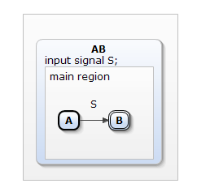 | 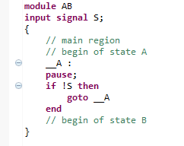 | 

