The SC Language (SCL) - SC Language & Graph

Page / - last modified by Alexander Schulz-Rosengarten on 2023/07/06 14:37

SC Language & Graph
last modified by Alexander Schulz-Rosengarten
on 2023/07/06 14:37

Table of Contents
The SC Language (SCL) and its graphical representation (SCG)
The SCL Meta-model
Deprecated since 0.12

- The SC Language (SCL) and its graphical representation (SCG)
- The SCL Meta-model
  - Deprecated since 0.12

The SC Language (SCL) and its graphical representation (SCG)
As mentioned in the introduction SCL is a minimal language. It consists of seven statements.
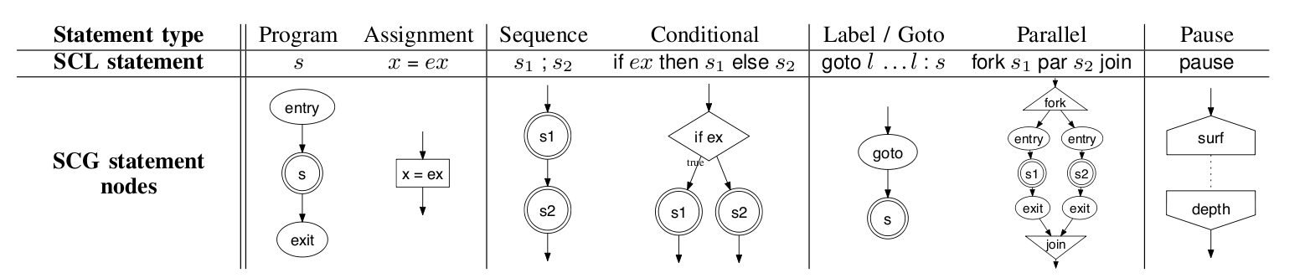
The SCG is a labelled graph G = (S, E), whereas
- the nodes S correspond to the statements of the program
- and the edges E reflect the sequential execution ordering
ABO example:
ABO SCL | ABO SCG
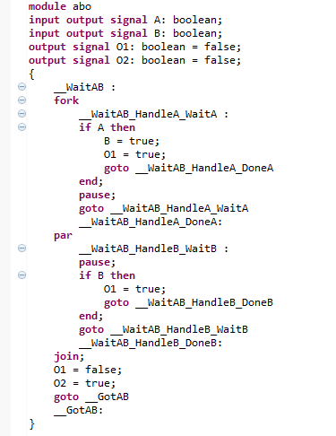 | 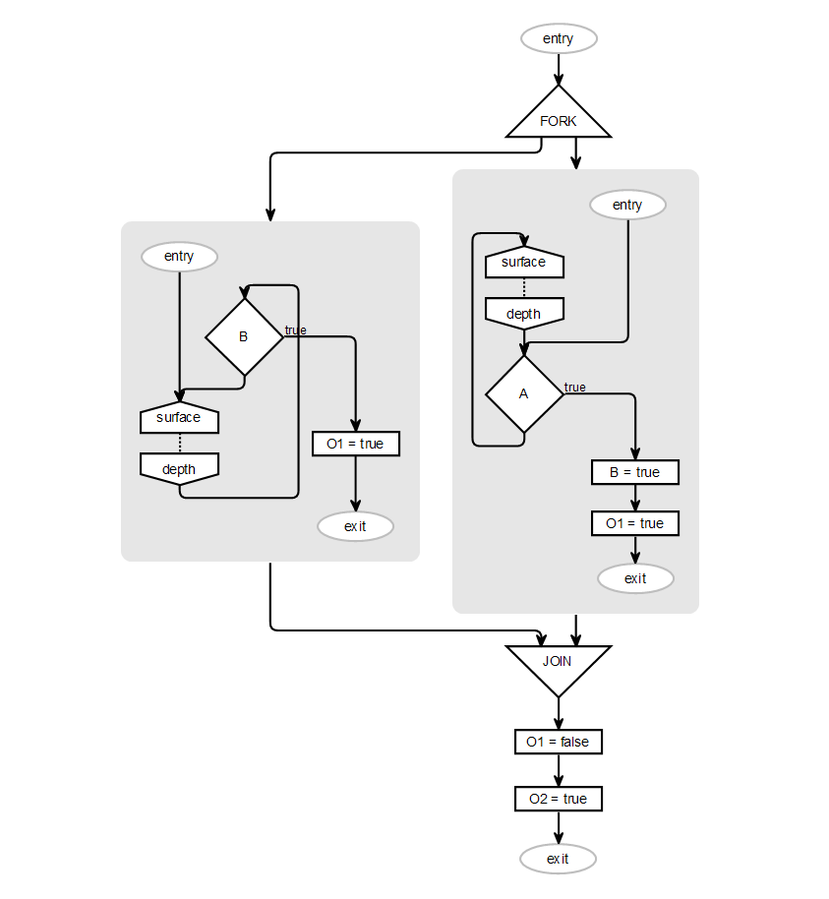

The SCL Meta-model

Deprecated since 0.12
This article is deprecated. The described features are no longer available in current releases.
The SC language is implemented in the plugin de.cau.cs.kieler.scl and created via xtext. The xtext grammar file is de.cau.cs.kieler.scl.SCL.xtext.
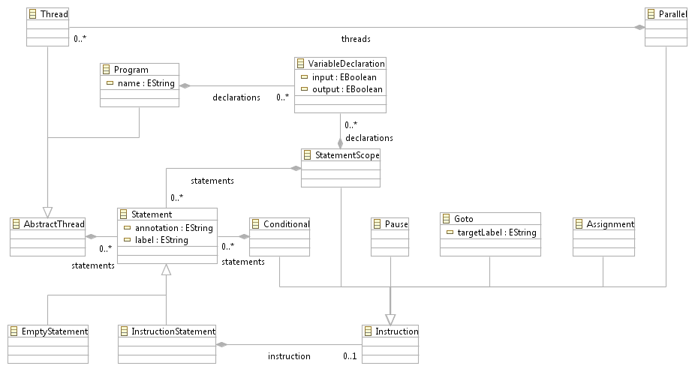
- Every SCL program is contained in a Program
- A Program and concurrent threads of a parallel statement a AbstractThreads
- AbstractThreads contain a list of Statements
- A Statement can either be a InstructionStatement and contains a single instruction or an EmptyStatement
- EmptyStatements do not contain an instruction, but can hold a label or an annotation
- An instruction is a Conditional, a Pause, a Goto, an Assignment, a Parallel or a new StatementScope

