SCCharts (pre 1.0) - Command Line Rendering

Page / - last modified by cmot on 2023/07/06 14:37

Command Line Rendering
last modified by cmot
on 2023/07/06 14:37

Table of Contents

Command Line Compiler Quick Start Guide (pre 0.13)

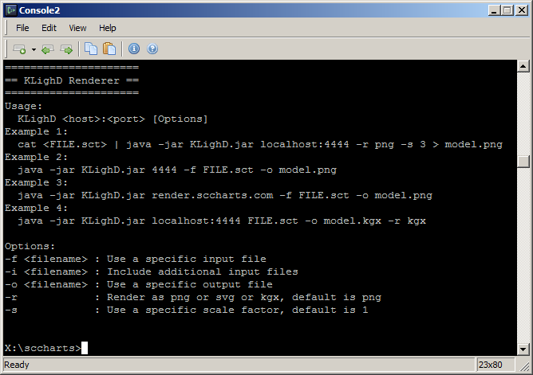
For rendering graphical SCCharts you might want to use the KLighD.jar as explained here here.
If you like to use the KLighD HTTP server provided, then use
render.sccharts.com:80
or as backup
sccharts.com:4445
as the host and port in your KLighD.jar call.

Example call:
java -jar KLighD.jar render.sccharts.com -f somescchart.sct -o somescchart.png -s 3 -r png

NEW: You can use -r kgx to output in the KIELER Graph (KGraph) format.

