Old Release Notes - KIELER Pragmatics Release 2016/02

Page / - last modified by Alexander Schulz-Rosengarten on 2023/09/07 14:26

KIELER Pragmatics Release 2016/02
last modified by Alexander Schulz-Rosengarten
on 2023/09/07 14:26

Table of Contents
KIELER Pragmatics 2016/02
Installation
Release Notes and Highlights
New Features
Quickstart
Diagram Layout
Viewing Ptolemy Models
Known Problems and Limitations
Bug Reports, Comments

KIELER Pragmatics 2016/02
- Official Project Website
- Built on Eclipse 4.4 "Luna"
We are happy to provide release 2016/02 of the KIELER Pragmatics Project! KIELER Pragmatics is a framework for enhanced user interaction in graphical modeling that builds on the Eclipse platform. This document describes how to install the release and highlights the most exciting new features.
As the usual bonus, we are co-releasing our KLighD-based KIELER Ptolemy Browser.
- KIELER Pragmatics 2016/02
  - Installation
  - Release Notes and Highlights
    - New Features
  - Quickstart
    - Diagram Layout
    - Viewing Ptolemy Models
  - Known Problems and Limitations
  - Bug Reports, Comments
Important Notice
Please note that this will be the last release to include the KIELER Infrastructure for Meta-Layout in its entirety, as well as our layout algorithms. Both are currently being moved to the official Eclipse Layout Kernel project.

Installation
KIELER Pragmatics 2016/02 is provided as a set of features, available to be added to your Eclipse installation via an update site. KIELER Pragmatics 2016/02 was tested on Eclipse 4.4 "Luna", but may also be compatible with other versions of Eclipse.
- See the KIELER Downloads site for download details.
- KIELER Pragmatics requires an installed Java Runtime Environment >= version 1.8.
- The layout components of KIELER can make use of the layout algorithms provided by the Graphviz library. You may want to install that as well.
Also refer to the KIELER Downloads page to download the KIELER Ptolemy Browser and the KIELER Web Service.

Release Notes and Highlights
For this release, we have closed more than 80 tickets. You can find a list of them at our issue tracking system. Release notes of older releases can be found at our Old Release Notes page.

New Features
Here's a few highlights of what's new in this version:
- KIELER Infrastructure for Meta Layout (KIML)
  - The infrastructure now includes a comment attachment framework. Comment attachment can be used to automatically infer which elements a comment refers to to keep comments from being placed arbitrarily.
- KIELER Layout Algorithms
  - The standalone distributables of our layout library has been expanded to allow developers more flexibility in choosing which parts of layout they want to use.
  - The layout infrastructure now supports more flexible hierarchy handling. It is now possible to enable hierarchical layout only for parts of a hierarchy tree.
  - KLay Layered has seen significant improvements when it comes to unnecessary whitespace.
- KIELER Lightweight Diagrams (KLighD)
  - KLighD (and KLay Layered) now support basic label management, which can reduce the details of labels dynamically.
- KIELER Ptolemy Browser
  - The Ptolemy browser can now show port labels in the diagram.

Quickstart

Diagram Layout
One of the core features of KIELER Pragmatics is the KIELER Infrastructure for Meta-Layout (KIML). It provides the glue between diagram editors and layout algorithms. If you have installed layout support for GMF editors, you may want to try the following:
- Open a diagram using a GMF editor.
- Press the Layout button in the toolbar:
- Open the Layout View by clicking Window -> Show View -> Other... and choosing Layout from the KIELER Layout category.
- Change some of the values and press the Layout button again.

Viewing Ptolemy Models
If you have a Ptolemy installation, try the following:
- Save a Ptolemy model as a .moml file somewhere.
- Download and start our Ptolemy Model Browser.
- Open your moml file.
- Double-click actors that have further models inside them. Also double-click modal model states that have refinements. Use the sidebar on the right to influence how your model is displayed.

Known Problems and Limitations
- Starting with Mac OS X Mountain Lion, trying to start our software may give you an error message similar to this:
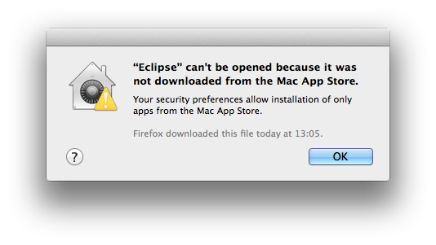
The solution is to open your system preferences and navigate to the Security & Privacy settings. Therein, either click on Open Anyway if available or change Allow apps downloaded from to Anywhere.
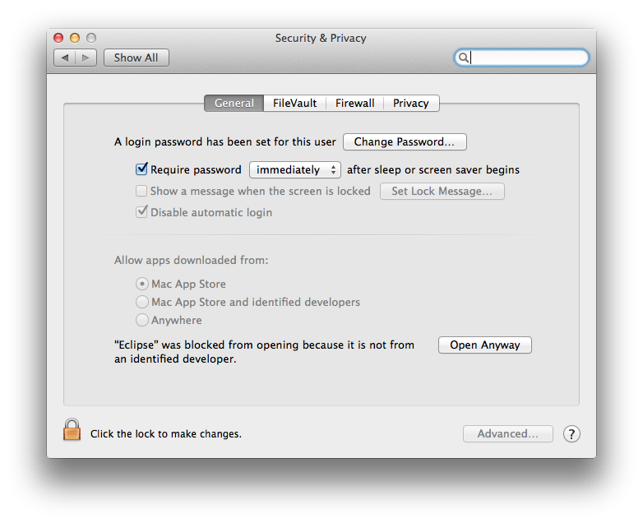
Starting our software will now result in the following message:
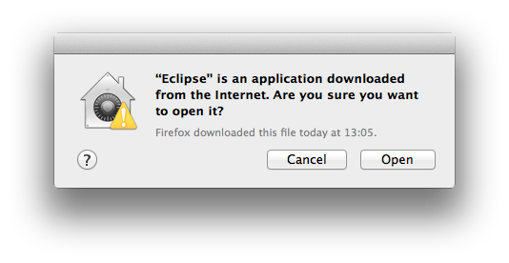
Simply click Open and you're good to go.
- Upon starting the Ptolemy Model Browser, you may get something like this:
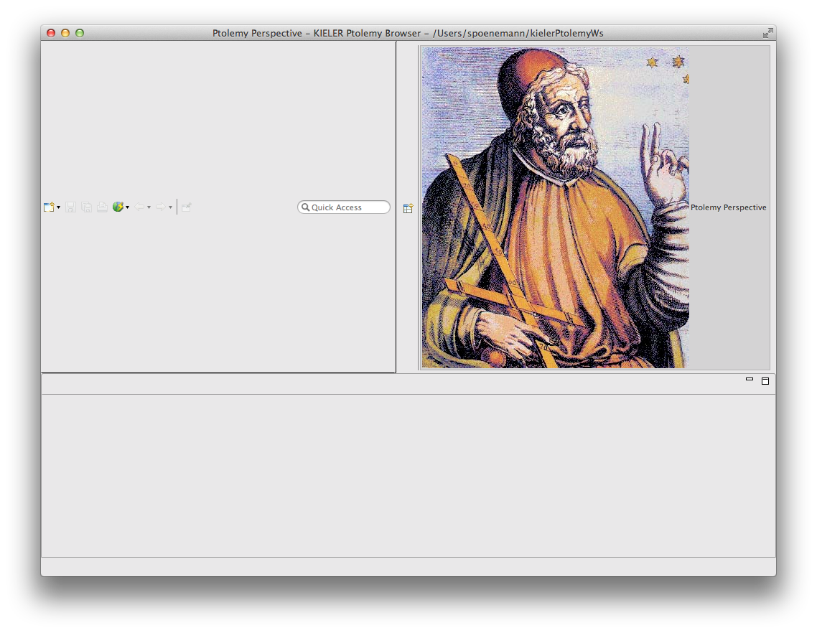
The solution is to exit the application, remove your existing workspace, and restart the Ptolemy Model Browser. Your workspace can be found in your home folder and is called kielerPtolemyWs.
- The Ptolemy Model Browser can properly display only a limited set of actors. Other actors may look a lot different than they do in Ptolemy.
- Currently there is no full-blown user documentation integrated. See our Kieler for more information.

Bug Reports, Comments
We're working hard to make the graphical modeling user experience as convenient as possible. However, bugs can still remain in the code and some things might not be as you would expect them. Please don't hesitate to send in bug reports or give other comments like feature requests.
Send bug reports to kieler@…, please. For news or general questions subscribe to the rt-kieler mailing list.

