Old Release Notes - KIELER Pragmatics Release 2015/06

Page / - last modified by Alexander Schulz-Rosengarten on 2023/07/11 10:25

KIELER Pragmatics Release 2015/06
last modified by Alexander Schulz-Rosengarten
on 2023/07/11 10:25

Table of Contents
KIELER Pragmatics 2015/06
Installation
Release Notes and Highlights
New Features
Important Fixed Bugs
Quickstart
Diagram Layout
Viewing Ptolemy Models
Known Problems and Limitations
Bug Reports, Comments

KIELER Pragmatics 2015/06
- Official Project Website
- Built on Eclipse 4.4 "Luna"
We are happy to provide release 2015/06 of the KIELER Pragmatics Project! KIELER Pragmatics is a framework for enhanced user interaction in graphical modeling that builds on the Eclipse platform. This document describes how to install the release and highlights the most exciting new features.
As the usual bonus, we are co-releasing our KLighD-based KIELER Ptolemy Browser.
- KIELER Pragmatics 2015/06
  - Installation
  - Release Notes and Highlights
    - New Features
    - Important Fixed Bugs
  - Quickstart
    - Diagram Layout
    - Viewing Ptolemy Models
  - Known Problems and Limitations
  - Bug Reports, Comments

Installation
KIELER Pragmatics 2015/06 is provided as a set of features, available to be added to your Eclipse installation via an update site. KIELER Pragmatics 2015/06 was tested on Eclipse 4.4 "Luna", but may also be compatible with other versions of Eclipse.
- See the KIELER Downloads site for download details.
- KIELER Pragmatics requires an installed Java Runtime Environment >= version 1.6.
- The layout components of KIELER can make use of the layout algorithms provided by the Graphviz library. You may want to install that.
Also refer to the KIELER Downloads page to download the KIELER Ptolemy Browser and the KIELER Web Service.

Release Notes and Highlights
For this release, we have solved almost 80 tickets. You can find a list of them at our issue tracking system. Release notes of older releases can be found at our Old Release Notes page.

New Features
Here's a few highlights of what's new in this version:
- KIELER Layout Algorithms
  - KLay Layered has seen substantial performance improvements, especially in its BK Node Placement algorithm.
  - KLay Layered's BK Node Placement algorithm has furthermore seen large improvements in the number of edges drawn straight.
To use it set the Properties.COMPACTION_STRATEGY to IMPROVE_STRAIGHTNESS.
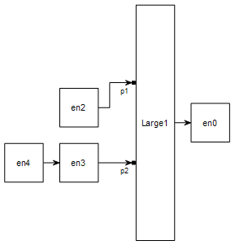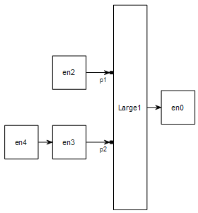
  - We have added a heuristic that improves the number of edge crossings to KLay Layered. The heuristic is active by default and should thus immediately improve your diagrams. Customize the heuristic through its layout option, Properties.GREEDY_SWITCH_TYPE.

Important Fixed Bugs
Among others, the following bugs were fixed in this version:
- KIELER KGraph Text
  - Fixed a bug that caused ConcurrentModificationExceptions to be thrown around all the time while editing the document.

Quickstart

Diagram Layout
One of the core features of KIELER Pragmatics is the KIELER Infrastructure for Meta-Layout (KIML). It provides the glue between diagram editors and layout algorithms. If you have installed layout support for GMF editors, you may want to try the following:
- Open a diagram using a GMF editor.
- Press the Layout button in the toolbar:
- Open the Layout View by clicking Window -> Show View -> Other... and choosing Layout from the KIELER Layout category.
- Change some of the values and press the Layout button again.

Viewing Ptolemy Models
If you have a Ptolemy installation, try the following:
- Save a Ptolemy model as a .moml file somewhere.
- Download and start our Ptolemy Model Browser.
- Open your moml file.
- Double-click actors that have further models inside them. Also double-click modal model states that have refinements. Use the sidebar on the right to influence how your model is displayed.

Known Problems and Limitations
- Starting with Mac OS X Mountain Lion, trying to start our software may give you an error message similar to this:
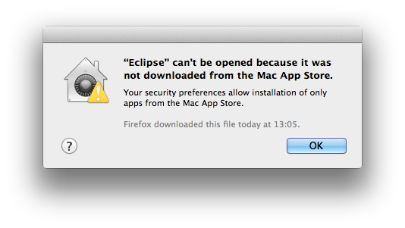
The solution is to open your system preferences and navigate to the Security & Privacy settings. Therein, either click on Open Anyway if available or change Allow apps downloaded from to Anywhere.
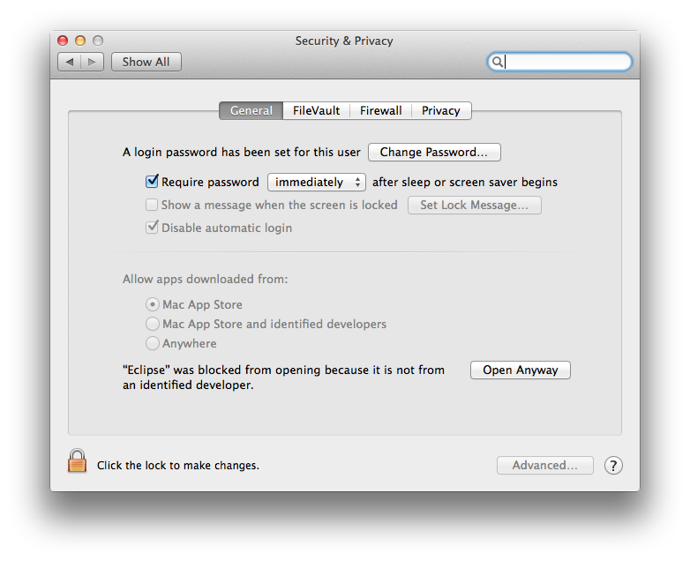
Starting our software will now result in the following message:
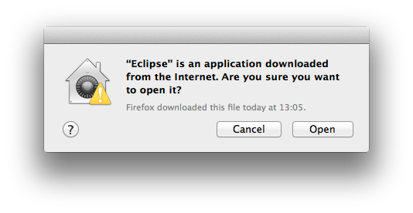
Simply click Open and you're good to go.
- Upon starting the Ptolemy Model Browser, you may get something like this:
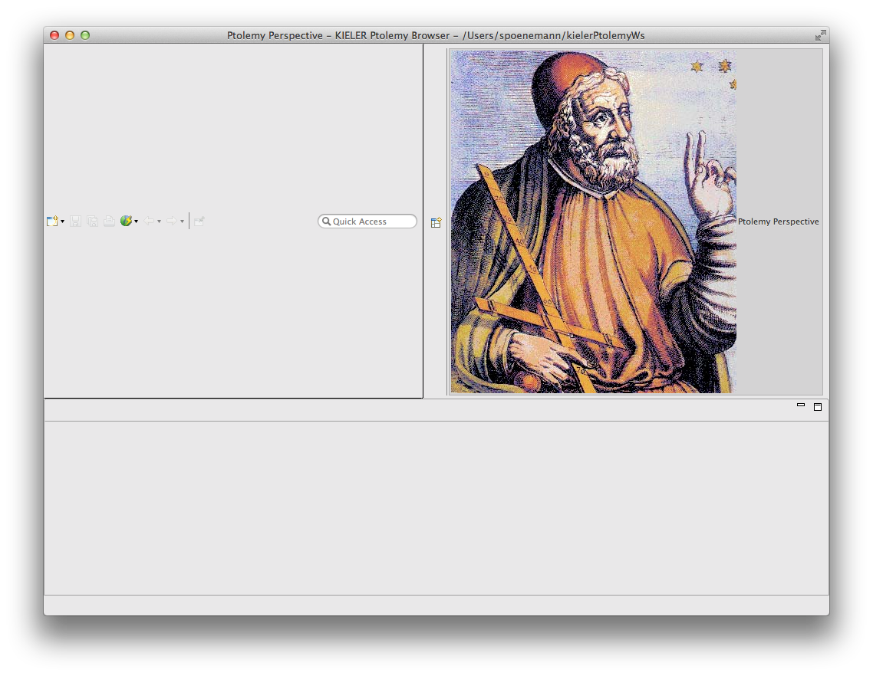
The solution is to exit the application, remove your existing workspace, and restart the Ptolemy Model Browser. Your workspace can be found in your home folder and is called kielerPtolemyWs.
- The Ptolemy Model Browser can properly display only a limited set of actors. Other actors may look a lot different than they do in Ptolemy.
- Currently there is no full-blown user documentation integrated. See our Kieler for more information.

Bug Reports, Comments
We're working hard to make the graphical modeling user experience as convenient as possible. However, bugs can still remain in the code and some things might not be as you would expect them. Please don't hesitate to send in bug reports or give other comments like feature requests.
Send bug reports to kieler@…, please. For news or general questions subscribe to the rt-kieler mailing list.

