Old Release Notes - KIELER Pragmatics Release 2014/12

Page / - last modified by uru on 2023/07/06 14:36

KIELER Pragmatics Release 2014/12
last modified by uru
on 2023/07/06 14:36

Table of Contents
KIELER Pragmatics 2014/12
Installation
Release Notes
API Changes in 2014/12
New Features Included in 2014/12
Important Bugs Fixed in 2014/12
Quickstart
Diagram Layout
Viewing Ptolemy Models
Known Problems and Limitations
Bug Reports, Comments

KIELER Pragmatics 2014/12
- Official Project Website
- Built on Eclipse 4.4 "Luna"
We are happy to provide release 2014/12 of the KIELER Pragmatics Project! KIELER Pragmatics is a framework for enhanced user interaction in graphical modeling that builds on the Eclipse platform. This document describes how to install the release and highlights the most exciting new features.
As a bonus, we are co-releasing our KLighD-based KIELER Ptolemy Browser.
- KIELER Pragmatics 2014/12
  - Installation
  - Release Notes
    - API Changes in 2014/12
    - New Features Included in 2014/12
    - Important Bugs Fixed in 2014/12
  - Quickstart
    - Diagram Layout
    - Viewing Ptolemy Models
  - Known Problems and Limitations
  - Bug Reports, Comments

Installation
KIELER Pragmatics 2014/12 is provided as a set of features, available to be added to your Eclipse installation via an update site. KIELER Pragmatics 2014/12 was tested on Eclipse 4.4 "Luna", but may also be compatible with other versions of Eclipse.
- See the KIELER Downloads site for download details.
- KIELER Pragmatics requires an installed Java Runtime Environment >= version 1.5.
- The layout components of KIELER can make use of the layout algorithms provided by the Graphviz library. You may want to install that.
Also refer to the KIELER Downloads page to download the KIELER Ptolemy Browser and the KIELER Web Service.

Release Notes
You can find a list of solved tickets for this release at our issue tracking system. Release notes of older releases can be found at our Old Release Notes page.
If you're wondering where components have gone that were traditionally a part of KIELER, you might not know yet that the KIELER was split into two separate projects, KIELER Pragmatics and KIELER Semantics, which release pretty much independently.

API Changes in 2014/12
This is a summary of the API changes introduced with version 2014/12:
- KIELER Layout Algorithms
  - KLay Layered's layout option Properties.MERGE_PORTS was renamed to Properties.MERGE_EDGES. Its ID was changed from de.cau.cs.kieler.klay.layered.mergePorts to de.cau.cs.kieler.klay.layered.mergeEdges.
  - Similarly, KLay Layered's layout option Properties.MERGE_HIERARCHICAL_PORTS was renamed to Properties.MERGE_HIERARCHICAL_EDGES. Its ID was changed from de.cau.cs.kieler.klay.layered.mergeHierarchicalPorts to de.cau.cs.kieler.klay.layered.mergeHierarchicalEdges.
  - The de.cau.cs.kieler.klay.layered.distributeNodes property was renamed to de.cau.cs.kieler.klay.layered.wideNodesOnMultipleLayers and allows for two modes now.

CAREFUL avoiding node/edge overlaps

AGGRESSIVE often more compact but does not guarantee to avoid node/edge overlaps
- KIELER Lightweight Diagrams
  - Feature composition changed s.t. de.cau.cs.kieler.klighd.feature only contains essential runtime plugins
    - does not require Xtext & KIELER KIVi anymore
    - those components are still part of our SDK feature de.cau.cs.kieler.klighd.sdk.feature
  - Plugin de.cau.cs.kieler.klighd.ui does not register the generic DiagramEditorPart and menu contributions like 'Save As Image...' anymore
    - registrations have been moved to plugin de.cau.cs.kieler.klighd.ui.contrib3x that is part of our SDK feature de.cau.cs.kieler.klighd.sdk.feature
    - nonetheless implementations remain at their previous place and can be specialized (subclassed)
  - Consolidation of the printing facilities
    - consolidation of the export branding infrastructure (see IExportBranding for details on that feature)

New Features Included in 2014/12
Here's a few highlights of what's new in version 2014/12:
- KIELER Layout Algorithms
  - A new interactive node placement algorithm in KLay Layered keeps the y coordinates of nodes intact if they don't overlap. This node placement algorithm is supposed to be used together with the interactive implementations of the other layout phases.
- KIELER Lightweight Diagrams* upcoming ViewChange notifications received by IViewChangeListeners can now be suppressed, see ViewChange.suppressSubsequent...Notifications(...)
  - introduced dedicated zoom style ZOOM_TO_FOCUS_AND_INCREASE_TO_FIT
    - 'increase to fit' behavior is now skipped while by applying the existing zoom style ZOOM_TO_FOCUS
  - KLighD now ships a generic graph visualization that allows to inspect the structure of graphs specified in any format that is supported by KIML.
  - The wizard for new KLighD projects received some love. We polished it's UI and generated code and added some tooltips.
  - We replaced the Batik SVG exporter with a customized exporter that is based on FreeHEP.

It supports semantic data to be added to the generated SVG.

Color gradients obey to the specified rotation angle.
- KGraph Editor Product
  - Layout options can now be configured using a textual DSL.
  - GrAna analyses can be specified using a textual DSL and executed either via the UI or headlessly.

Important Bugs Fixed in 2014/12
Among others, the following bugs were fixed in version 2014/12:
- KIELER Layout Algorithms
  - Computing layouts with the layout direction set to UP failed for compound nodes in KLay Layered.
  - KLay Force allowed the object spacing to be zero, which does not make sense and, more importantly, crashed the algorithm.
- KGraph Text
  - Converting KGX files into the KGT format failed when certain properties were set.
- KIELER Lightweight Diagrams
  - We fixed an issue where the allocated memory of views was not released properly.

Quickstart

Diagram Layout
One of the core features of KIELER Pragmatics is the KIELER Infrastructure for Meta-Layout (KIML). It provides the glue between diagram editors and layout algorithms. If you have installed layout support for GMF editors, you may want to try the following:
- Open a diagram using a GMF editor.
- Press the Layout button in the toolbar:
- Open the Layout View by clicking Window -> Show View -> Other... and choosing Layout from the KIELER Layout category.
- Change some of the values and press the Layout button again.

Viewing Ptolemy Models
If you have a Ptolemy installation, try the following:
- Save a Ptolemy model as a .moml file somewhere.
- Download and start our Ptolemy Model Browser.
- Open your moml file.
- Double-click actors that have further models inside them. Also double-click modal model states that have refinements. Use the sidebar on the right to influence how your model is displayed.

Known Problems and Limitations
- Starting with Mac OS X Mountain Lion, trying to start our software may give you an error message similar to this:
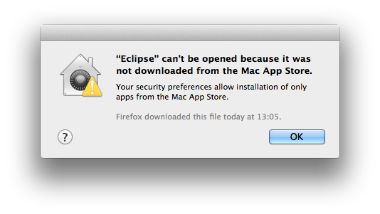
The solution is to open your system preferences and navigate to the Security & Privacy settings. Therein, either click on Open Anyway if available or change Allow apps downloaded from to Anywhere.
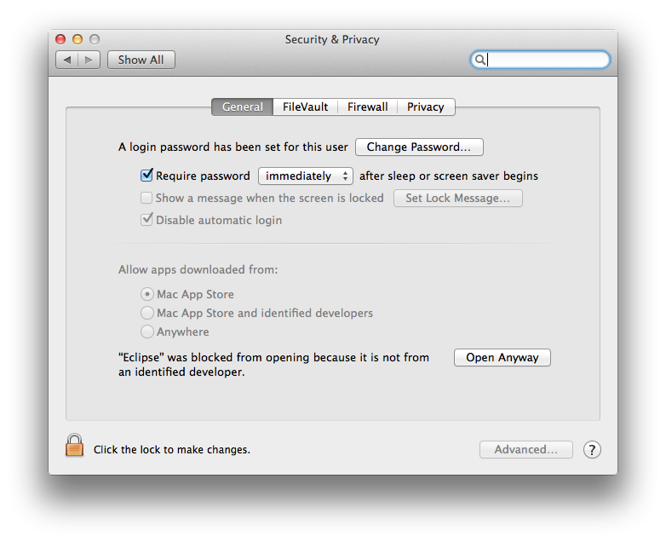
Starting our software will now result in the following message:
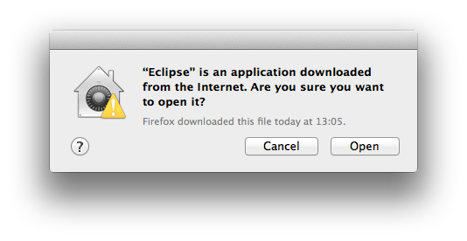
Simply click Open and you're good to go.
- Upon starting the Ptolemy Model Browser, you may get something like this:
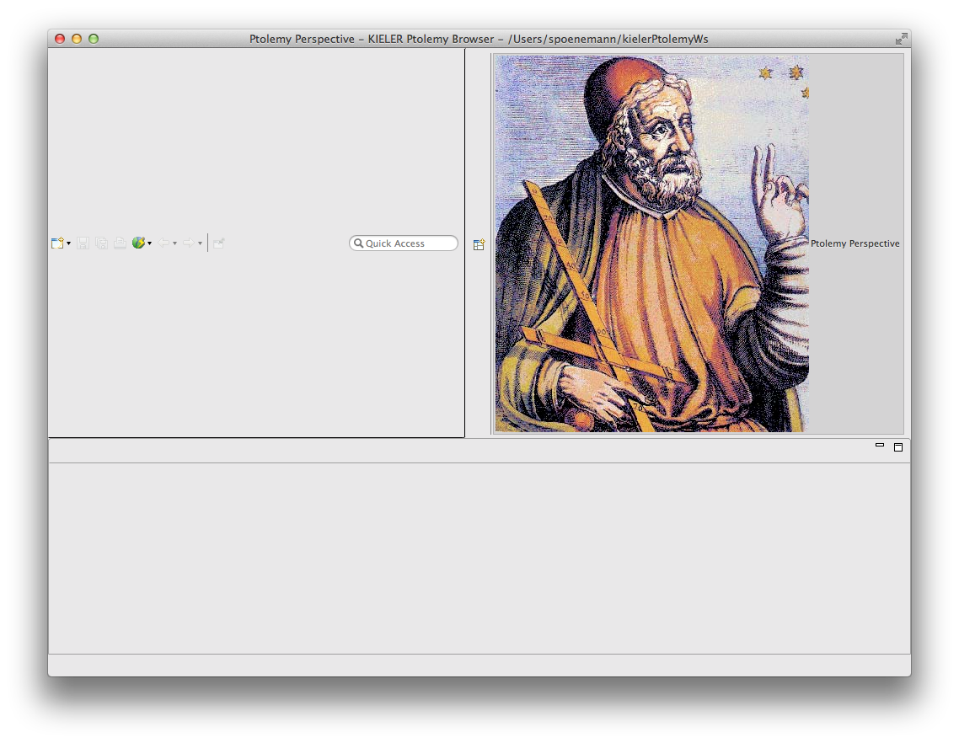
The solution is to exit the application, remove your existing workspace, and restart the Ptolemy Model Browser. Your workspace can be found in your home folder and is called kielerPtolemyWs.
- The Ptolemy Model Browser can properly display only a limited set of actors. Other actors may look a lot different than they do in Ptolemy.
- Currently there is no full-blown user documentation integrated. See our Kieler for more information.

Bug Reports, Comments
We're working hard to make the graphical modeling user experience as convenient as possible. However, bugs can still remain in the code and some things might not be as you would expect them. Please don't hesitate to send in bug reports or give other comments like feature requests.
Send bug reports to kieler@…, please. For news or general questions subscribe to the rt-kieler mailing list.

