Eclipse Layout Kernel (ELK) - Textual Layout Configuration

Page / - last modified by uru on 2023/07/11 10:33

Textual Layout Configuration
last modified by uru
on 2023/07/11 10:33

Table of Contents
Plugins

Developing layout algorithms involves playing around with layout options. Setting the options using ELK's Layout View or programmatically can be quite tedious. This is where the Textual Layout View may come in handy. It allows to specify a layout algorithm alongside its layout options using a small DSL. It is also possible to specify a chain of layout algorithms, as seen on the right side of the following screenshot. Note that this does only make sense if the latter algorithms make use of the previously computed positions in some way.

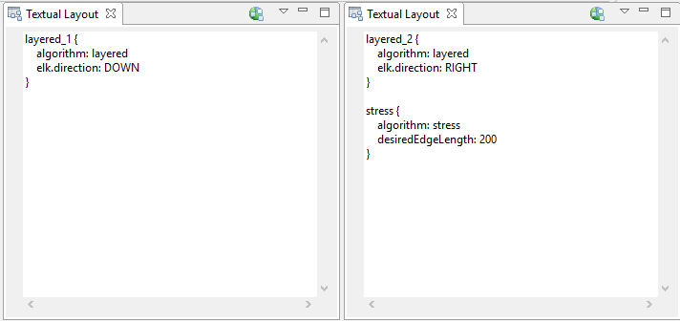

Plugins
- de.cau.cs.kieler.config.text
- de.cau.cs.kieler.config.text.ide
- de.cau.cs.kieler.config.text.ui

