Discontinued Projects - Visual Kompare (KIViK)

Page / - last modified by Richard Kreissig on 2023/09/14 10:34

Visual Kompare (KIViK)
last modified by Richard Kreissig
on 2023/09/14 10:34

Table of Contents
Project Overview

Legacy Project
KIViK is currently not maintained and hence not part of the KIELER release. Source code is only available for Eclipse 3.3.

Project Overview
Related Theses:
- Arne Schipper, Layout and Visual Comparison of Statecharts, December 2008 (pdf)
Statecharts are a generally accepted method to model safety critical reactive systems, reducing modeling errors of the developers. As Statecharts are inherently graphical, two problems arise when working with them. One issue is to receive a sound layout of Statecharts automatically, the other addresses the comparison of Statecharts at the diagram level.
Much research has already been done considering layout and automatic layout of Statecharts. This thesis continues these works and provides an implementation of a framework enabling Statechart layout in Eclipse. Great importance is attached to meta layout facilities, enabling different layout types for different parts of a Statechart. This can be exploited by pattern-based layout, increasing the readability and comprehensiveness.
Working with projects usually results in the need to compare different versions of files. So far, there is no useful solution to compare Statecharts visually. This thesis evaluates several possible approaches and presents one promising one. As a proof of concept, and for later use in a meta-tool framework, both proposals are implemented in Eclipse.
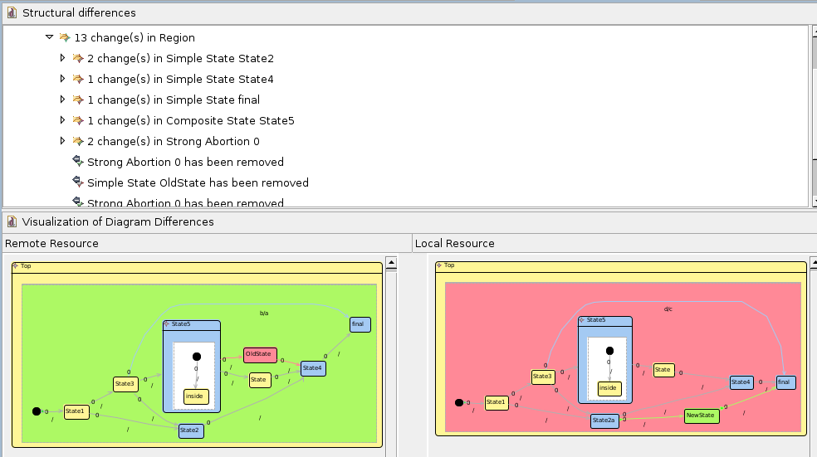
KiViK compare window

