Processes - Build Management

Page / - last modified by Richard Kreissig on 2023/09/14 08:50

Build Management
last modified by Richard Kreissig
on 2023/09/14 08:50

Table of Contents
An Overview of KIELER Build Automation
Software We Use
Maven / Tycho
Apache Ant
Bamboo
The Automatic Build Process
POM Files
Using the KIELER Maven Build
What to Be Aware of
Continuous and Nightly Builds
Update Sites and Redistributables

An Overview of KIELER Build Automation
In order to keep the KIELER code as stable as possible, we use automatic continuous integration builds. Once you push something into one of the KIELER repositories, you trigger the automatic build process. If the build fails for whatever reason – be it failed unit tests or simply compilation errors – you are notified of the problem.
This page describes the software and setup we use to implement all of this.
Content
- An Overview of KIELER Build Automation
  - Software We Use
    - Maven / Tycho
    - Apache Ant
    - Bamboo
  - The Automatic Build Process
    - POM Files
    - Using the KIELER Maven Build
    - What to Be Aware of
  - Continuous and Nightly Builds
  - Update Sites and Redistributables

Software We Use
To implement our automatic builds, we use the popular Maven tool in conjunction with Tycho, a set of Maven plug-ins that allow Maven to build Eclipse projects. Our KLay layouters library is built using Apache Ant. To implement our continuous integration builds, we use Atlassian Bamboo.

Maven / Tycho
Maven is a build tool for Java projects. It takes care of dependency management, including in-build dependencies (the order in which packages are compiled) as well as dependencies to third-party libraries. The latter are automatically fetched from special Maven repositories. Without getting too technical, a Maven build consists of several phases, such as compile and package. Within each phase, several Maven plug-ins handle different tasks (or goals, as Maven calls them). The maven-compile-plugin for example compiles .java files into .class files.
To correctly compile a project, Maven needs to be told about the project. While the popular Ant build tool uses build.xml files to describe the steps to be executed for building a project, Maven uses pom.xml files to describe the project and figures out the steps for itself. The POM files may inherit settings from a parent POM file.
Tycho is a set of Maven plugins that handles compiling and dependency management as well as bundling of Eclipse plug-ins. Tycho understands Eclipse metadata files such as plugin.xml or feature.xml, provides dependency information extracted from those files, and provides an Eclipse instance for compiling and packaging Eclipse bundles.

Apache Ant
Ant is a very popular Java build tool. While Maven wants to know metadata about a project and then knows what to do to build it, Ant works by specifying exactly what to do to build a project. These steps are configured in a build.xml file. We try to avoid using Ant, but still have Ant build files around for jobs too specialized to be properly handled by Maven.

Bamboo
While Maven and Tycho know how to compile KIELER, Bamboo knows when to compile KIELER and what to do with the compiled project. Bamboo has access to our source code repositories and triggers continuous integration builds every time someone pushes new code into a repository. It also does a full build every night and copies the results onto our nightly build update site to be accessed by people all around the world. And beyond. Tell your friends!

The Automatic Build Process
This section describes how our POM files are distributed throughout the repository structure, and how you can trigger an automatic build of KIELER.

POM Files
The basic structure of the POM files is the same for both, the pragmatics and semantics repository, and can be seen below:
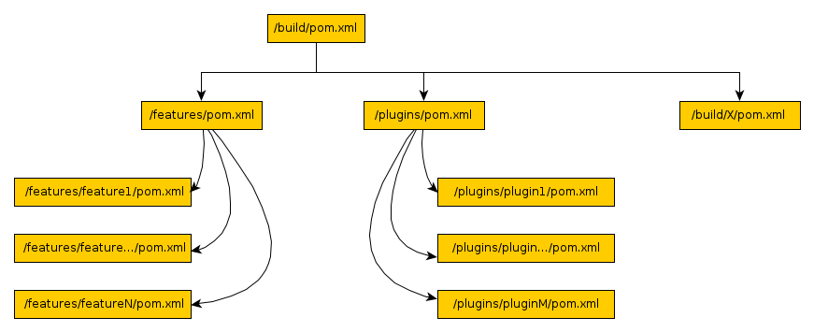
Each plug-in and feature has a corresponding (usually rather small) POM file. The POM files in the features and plugins directories know about the different features and plug-ins. The parent POM file, which all other POM files copy basic configuration from, knows about the feature and plug-in POM files, as well as about every kind of build configuration we have (for building the pragmatics repository, for building the KWebS product, etc.). In addition, the build directory also contains a bunch of subdirectories housing POM files that produce our p2 repositories and our products.

Using the KIELER Maven Build
Using the KIELER Maven build requires two things: a working Maven installation (d'oh...) and knowledge about how exactly to trigger a build. We leave the former to you, but the latter is what this section is about.
To actually build KIELER, navigate to the /build/ directory and run the following command line:
. /home/java/java-env # Only necessary when working on our servers
mvn clean package -P <profile>
Once Maven has finished, the different build artifacts may be found in the /build/de.cau.cs.kieler.<profile>.repository/target directories. The following build profiles are available in the KIELER Pragmatics repository:
- klighdning – Builds a standalone version of the KLighDning server, based on the current nightly pragmatics update site.
- kwebs – Builds a standalone version of the KWebS server, based on the current nightly pragmatics update site.
- pragmatics – Builds a p2 repository that contains our pragmatics features. This is what would usually be pushed online for people to download as our nightly pragmatics build.
- ptolemy-rcp – Produces a standalone version of our Ptolemy Model Viewer, based on the current nightly build pragmatics update site.
The following build profiles are available in the KIELER Semantics repository:
ToDo
Document the Semantics build profiles.

What to Be Aware of
There are some things that people need to be aware of to keep the build files in a valid state.
- Eclipse metadata and POM files are not synchronized. Thus, if the version of an Eclipse plug-in changes, its pom.xml needs to be updated accordingly.
- The repository POM directories contain product files and product icons. These are copies of the files found in the corresponding branding plug-ing (such as de.cau.cs.kieler.core.product) and have to be manually synchronized.

Continuous and Nightly Builds
There are basically four different kinds of build plans for each of the KIELER projects:
- Continuous Plugins – Compiles the plug-ins and runs the unit tests on them. None of the compiled artifacts are published anywhere (in fact, no update site or product is even produced). This plan is triggered by pushing stuff into the repositories, giving early feedback regarding whether committed changes break anything.
- Nightly <Product> – Assembles distributable product files and/or update sites. Distributable files are published in the nightly build directory /home/kieler/public_html/files/nightly. Update sites are published in /home/kieler/public_html/updatesite/nightly. These plans are run once every night.
- Nightly Rating – Compiles the plug-ins and runs our code quality rating doclet on them. The result is a website published at /home/kieler/public_html/rating. This plan is run once every night.
- Release Builds – Continuous builds of release branches once a release is imminent. These usually run whenever changes are pushed into the repository. All release builds are placed in a special Bamboo project calles KIELER Releases.
The Semantics project has an additional build plan:
- Ptolemy Update Site – Builds the Ptolemy library and produces an update site for it. The build is triggered whenever changes are pushed into the Ptolemy repository. This build plan is necessary since both, the Pragmatics and the Semantics projects use the Ptolemy libraries.

Update Sites and Redistributables
Our automatic builds produce a bunch of so-called artifacts: redistributable applications as well as a number of update sites. This table lists all artifacts, the project or repository they belong to, the build file responsible for producing them, the Bamboo build plan that builds them, and the directory they are finally placed in.
Timestamps
Don't be alarmed if the timestamps of the plugin and feature jar files on the updatesite don't match the current time. The time is probably UTC. Which is nice.
Artifact | Repository | Build File | Bamboo Build Plan | Final Directory
KWebS RCA | Pragmatics | ...kwebs.repository/pom.xml | KIELER Pragmatics -> Nightly KWebS | /home/kieler/public_html/files/nightly/kwebs
KIELER Pragmatics Updatesite | Pragmatics | ...pragmatics.repository/pom.xml | KIELER Pragmatics -> Nightly Pragmatics Updatesite | /home/kieler/public_html/updatesite/nightly/pragmatics/
Papyrus Layout Updatesite | Pragmatics | ...papyrus.repository/pom.xml | KIELER Pragmatics -> Nightly Papyrus Updatesite | /home/kieler/public_html/updatesite/nightly-papyrus/
KIELER RCA | Semantics | ...semantics.repository/pom.xml | KIELER Semantics -> Nightly Semantics Product | /home/kieler/public_html/files/nightly/
KIELER Semantics Updatesite | Semantics | ...semantics.repository/pom.xml | KIELER Semantics -> Nightly Semantics Updatesite | /home/kieler/public_html/updatesite/nightly/semantics/
Ptolemy Libraries Updatesite | Ptolemy | ...ptolemy.repository/pom.xml | KIELER Semantics -> Ptolemy Updatesite | /home/kieler/public_html/updatesite/ptolemy/

