Help - Macros

Page / - last modified by Sascha Hoppe on 2023/07/06 10:42

Macros
last modified by Sascha Hoppe
on 2023/07/06 10:42

Table of Contents
Examples

Use Macros
Macros are reusable pieces of functionality that can be integrated inside pages.
The WYSIWYG Editor allows you to insert macros and to customize their parameters when editing pages. Look for the button on the tool bar.
Try it!
× Use Macros
Close

Browse Macros
Choose from community contributed macros and install them inside your wiki.
The Macro Index lists the macros that are already installed and ready to be used inside your pages.
Browse Learn more
× Browse Macros
Close

Examples
Need help or confused with some of our macros? Check out their documentation and find out more about their functionality.
Box
Displays a message in a styled box.
- See examples
- Learn more
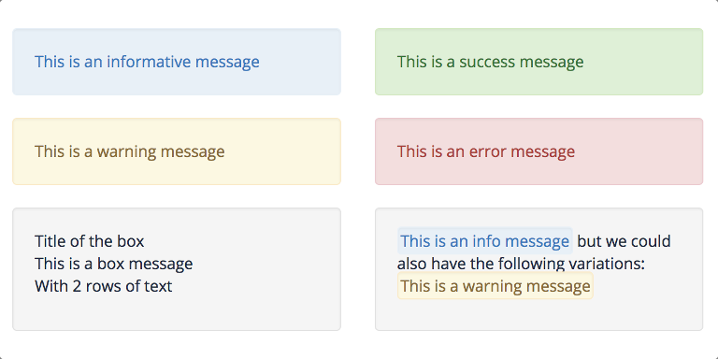
Table of Contents
Generates a table of contents for the page headings.
- See examples
- Learn more
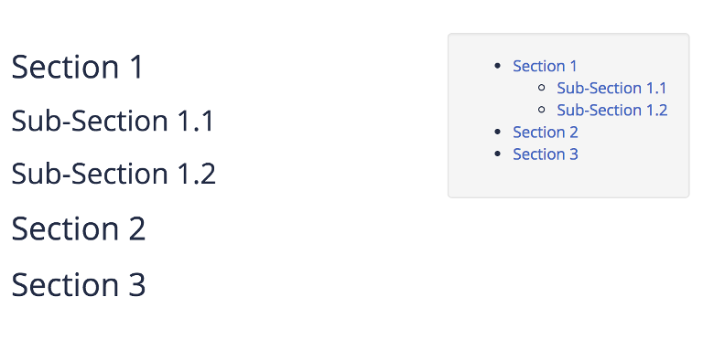
Gallery
Displays a list of images in a slide-show gallery.
- See examples
- Learn more
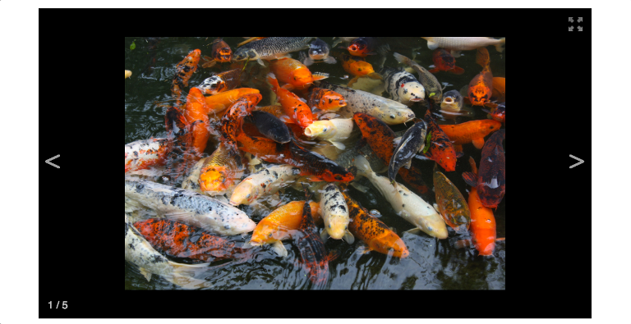
Chart
Generates graphical charts from data sources.
- See examples
- Learn more
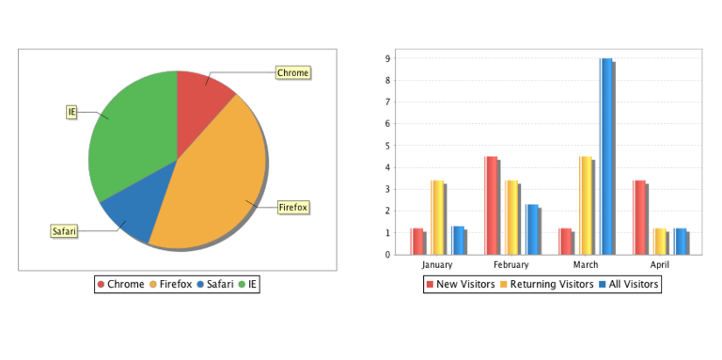
Page Tree
Displays the hierarchy of pages.
- See examples
- Learn more
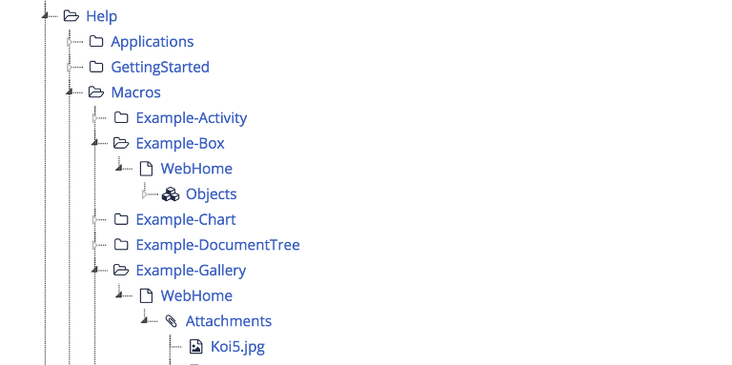
Notifications
Displays recent activities done on pages by the users.
- See examples
- Learn more
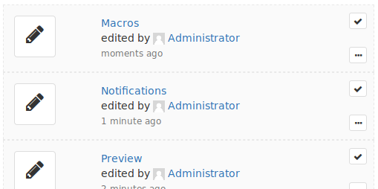
View more macros

